**Worksheet: Module 4**

CS 315: Data Structures and Algorithms

Richard S. Stansbury

Embry-Riddle Aeronautical University

Daytona Beach, FL

Student: Jeremiah Webb

ID: 25454328

**Problem #1:**

Given the data: 3, 12, 44, 99, 72, 33, 11, 18, 65, 42

Sort the data and draw out a trace of the execution using ***Merge Sort.***

Step Instruction (Swap values refer to the actual values themselves, not the index).

0 merge(arr, 0, 0, 1) Right Subarray: Swapping 12 12

1 merge(arr, 0, 1, 2) Right Subarray: Swapping 44 44

2 merge(arr, 3, 3, 4) Left Subarray: Swapping 99 72

3 merge(arr, 0, 2, 4) Right Subarray: Swapping 72 72, Right Subarray: Swapping 99 99

4 merge(arr, 5, 5, 6) Left Subarray: Swapping 33 11

5 merge(arr, 5, 6, 7) Left Subarray: Swapping 33 18

6 merge(arr, 8, 8, 9) Left Subarray: Swapping 65 42

7 merge(arr, 5, 7, 9) Right Subarray: Swapping 42 42, Right Subarray: Swapping 65 65

8 merge(arr, 0, 4, 9) Left Subarray: Swapping 72 42, Left Subarray: Swapping 99 65

***Final: 3 11 12 18 33 42 44 65 72 99***

**Problem #2:**

Given the data: 8, 6, 7, 5, 3, 0, 9, 99, 44, 100, 11

Sort the data and draw out a trace of the execution using ***Merge Sort.***

Step Instruction (Swap values refer to the actual values themselves, not the index).

0 merge(arr, 0, 0, 1) Left Subarray: Swapping 8,6

1 merge(arr, 0, 1, 2) Left Subarray: Swapping 8,7

2 merge(arr, 3, 3, 4) Left Subarray: Swapping 5,3

3 merge(arr, 3, 4, 5) Left Subarray: Swapping 5,3

4 merge(arr, 0, 2, 5) Left Subarray: Swapping 5,0 & Swapping 7,3 & Swapping 8, 5

5 merge(arr, 6, 6, 7) Right Subarray: Swapping 99,99

6 merge(arr, 6, 7, 8) Left Subarray: Swapping 99, 44

7 merge(arr, 9, 9, 10) Left Subarray: Swapping 100, 11

8 merge(arr, 6, 8, 10) Right Subarray: Swapping 100, 100

9 merge(arr, 0, 5, 10) Right Subarray: Swapping 9,9 & Swapping 11,11 & Swapping 44,44 & Swapping 99, 99 Swapping 100

***Final: 0 3 5 6 7 8 9 11 44 99 100***

**Problem #3:**

Given the data: 3, 12, 44, 99, 72, 33, 11, 18, 65, 42

Partition the array using the first index as the pivot value v using the Partition algorithm.

1. Trace your execution
2. Label and show your final array with pivot location labeled
3. Write out the index of j the pivot.

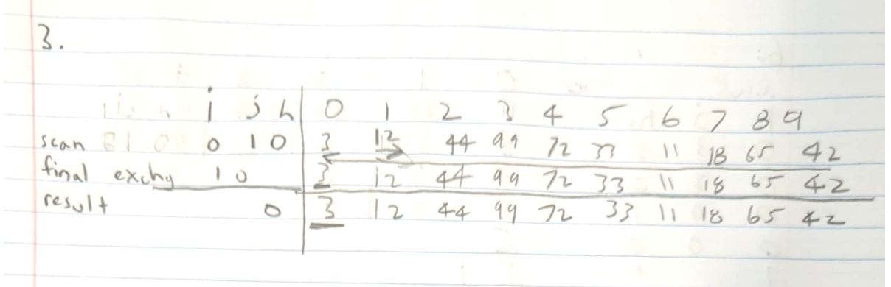

**Problem #4:**

Given the data: 8, 6, 7, 5, 3, 0, 9, 99, 44, 100, 11

Partition the array using the first index as the pivot value v using the Partition algorithm.

1. Trace your execution
2. Label and show your final array with pivot location labeled
3. Write out the index of j the pivot.

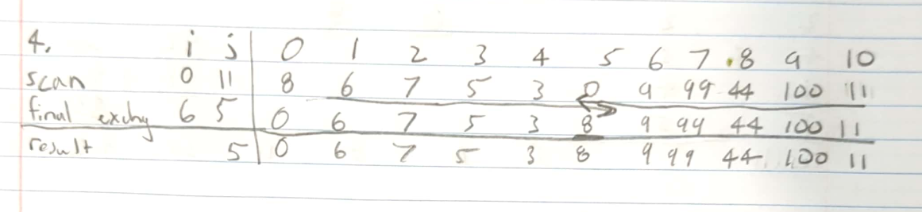

**Problem #5:**

Given the data: 11, 38, 42, 8, 6, 5

Partition the array using the first index as the pivot value v using the Partition algorithm.

1. Trace your execution
2. Label and show your final array with pivot location labeled
3. Write out the index of j the pivot.

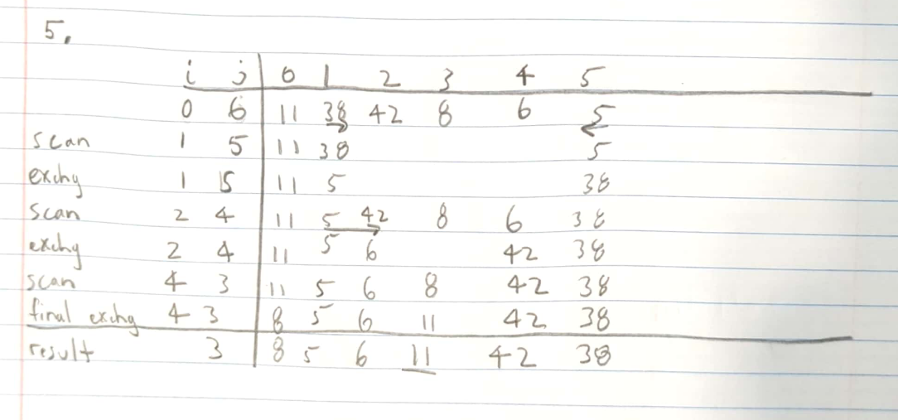

**Problem #6:**

Given the data: 11, 38, 42, 8, 6, 5

Trace the execution of quicksort. You do not need to sort your array initially as shown in the book (this helps me grade 😊).

